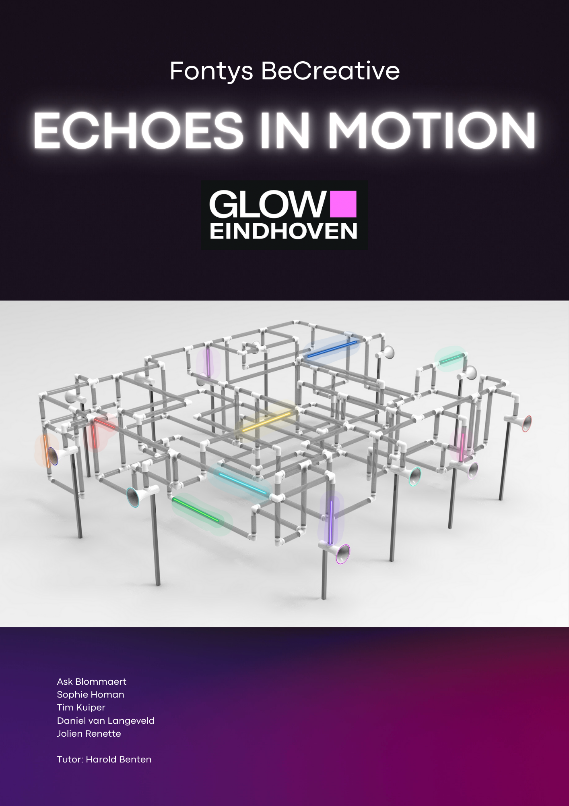

Preface

This project is part of the Fontys minor BeCreative, which took place from February to July 2024 at Fontys Engineering in Eindhoven. Within this minor there are various projects which can be done, including this GLOW project, where students design an installation for the GLOW festival held in November 2024. This report describes the entire development process of the installation, from the initial concepts to the final realization of the prototype.

The project was carried out by five students, each from different majors: Ask Blommaert (ICT), Sophie Homan (Mechanical Engineering), Tim Kuiper (Mechanical Engineering), Daniel van Langeveld (Electrical Engineering), and Jolien Renette (Industrial Product Design).

We would like to thank a number of people. In particular, we would like to thank Harold Benten, our tutor, for his valuable guidance throughout the entire project. We are also indebted to the GLOW team for their support and the opportunity to present our work at the festival. Finally, we want to express our gratitude to the companies that supported and sponsored our project.

June 13th 2024

Summary

The GLOW Festival in Eindhoven has been an annual event since 2006, showcasing innovative light art from international and local artists. Focused on light art and accessibility, the festival has grown significantly, attracting over 900,000 visitors by 2016 and gaining international recognition. The festival emphasizes innovation and also organizes the GLOW Academy, which involves students in creating light installations.

Fontys BeCreative is a program for third and fourth-year students with technical backgrounds. It consists out of several projects, one of them being the GLOW project. It focuses on project-based learning, allowing students to design and build installations for the GLOW Festival. The program runs for half a school year, with the spring semester for developing ideas and prototypes, and the fall semester for constructing the final installation.

The team that made this report aimed to create an engaging, interactive installation for the November festival. The project required research to ensure a smooth transition for the next team to complete the installation. The project is split between a prototype team (February-July 2024) and an upscaling team (September-November 2024). When the current project is done, the upscaling team will brainstorm for the GLOW of 2025. This report is made by the prototype team. The installation needs to withstand outdoor conditions, including wind and snow, requiring waterproof electronics. The team had creative freedom within the festival's theme, guided by the BeCreative method of brainstorming and concept development. The installation had to meet the GLOW organization's requirements, including a prototype by June and documentation and pre-ordered parts for the next team. Additional sponsorships were needed to increase the budget.

Using the BeCreative method, each team member generated 20 ideas, narrowed down to a top five, and then refined to two final concepts: "The Grid" and "Pipes." "The Grid" visualized energy flow, while "Pipes" focused on light and sound interaction through a network of pipes. "Pipes" was chosen based on audience votes at a GLOW Academy event and evolved into "Echoes in Motion." This installation features interconnected pipes with horns that transmit light and sound, symbolizing digital communication and promoting empathy and dialogue.

The prototype includes three horns at a 1:1 scale. The final installation will be a complex network of pipes with horns at varying heights for accessibility. The mechanical part includes satin pipes housing transparent pipes which in turn houses LED strips and cables, 3D-printed horns and different types of cross sections. To withstand outdoor conditions, the horns and cross sections are waterproofed with O-rings and sealants. The electrical design includes microphones, speakers, RGB LEDs, and a control system using ESP32 boards. The light system requires 12V RGB LED strips, which use most of the system's energy. The software manages light and sound interactions, with a self-discovery system for modules to communicate and create a network map, using serial data pass-through for communication.

The report details the process of designing and developing the "Echoes in Motion" installation for the GLOW Festival. It highlights the importance of innovation, collaboration, and technical skills in creating an interactive light art installation. Recommendations include acquiring or creating a DSP for audio switching, implementing hardware communication to replace Wi-Fi, ensuring stable connections, adding LED visual feedback, preventing message retransmissions, refining audio triggering, completing the pathfinding algorithm, and enhancing module self-discovery. These steps aim to improve the installation's robustness and interactivity for future versions.

List of Abbreviations

|  |  |
| --- | --- |
| RGB | Red, Green, Blue, usually used for lighting |
| DSP | Digital Signal Processor |
| ESP32 | Type of micro controller |
| SRD | System Requirements Document |
| OTA | Over The Air, indicating wireless capability |
| PCB | Printed circuit Board |
| OpAmp | Operational Amplifier |
|  |  |

Contents

Introduction 5

1. Background 6

1.1 GLOW festival 6

1.2 Fontys BeCreative 6

2. Problem analysis 7

2.1 Problem description 7

2.2 Research goal 7

2.3 Conditions & restrictions 7

2.4 Approach 8

2.5 Requirements 8

3. Concepts & Story 9

3.1 Brainstorming & Fontys BeCreative method 9

3.2 Concepts 9

3.3 Testing & Final Idea 10

3.4 Pipes: 6 concepts 11

3.5 Final concept (whole installation) 12

3.6 Story 12

4. Construction & Development 13

4.1 Prototyping 13

4.2 Final Installation 13

4.3 Mechanical Design 14

4.4 Electrical design 16

4.5 Software 19

5. Promotion & Sponsoring 21

5.1 Website 21

5.2 Sponsorships 21

6. Future & Financing 22

6.1 Preparation Future 22

6.2 Financing 22

7. Conclusion & Recommendations 23

7.1 Conclusion 23

7.2 Recommendations 23

References 25

Appendixes 26

Appendix A SRD 26

Appendix B Mechanical Design Components 34

Appendix C Electrical circuits and PCB designs 39

Appendix D BOM & costs 41

Appendix E Task division 43

# Introduction

Every November the city of Eindhoven lights up with all kinds of artworks and installations during the GLOW festival. GLOW is a free to attend light festival in the centre of Eindhoven. The festival attracts hundreds of thousands of people every year, who walk the route through the city centre. The artists are both famous and lesser-known artists from the Netherlands and abroad. Every year there are also student teams that participate in the GLOW festival. This report is about the process of one of these student teams; from idea to the prototype of ‘Echoes in Motion’.

Echoes in Motion is a project that reflects the dynamics of digital communication, highlighting how messages travel through the internet without speakers fully understanding their impact. It aims to raise awareness about the effects of online interactions by providing a visual representation of how words travel to recipients, promoting empathy and constructive dialogue. The interaction begins with users speaking into a horn, each with a unique colour. A network of tubes determines the possible light paths, which users can influence to create a personalized light and sound experience. As the sound reaches sensors, light travels through the pipes, with the light path length changing dynamically based on the speech duration, making each interaction distinct and engaging.

This report serves as the final deliverable for one of the Fontys minor BeCreative projects. From February to July, a team of students worked on designing and prototyping an installation for GLOW. The purpose of this report is to inform and guide the next team that will continue the project after the summer vacation. It details the process up to the prototype stage. The incoming team will be responsible for completing the installation for display at GLOW, making it essential for them to be thoroughly informed. This report will serve as a manual to guide them through the project's continuation.

The report consists of several chapters. The first chapter addresses the background of the GLOW festival and the Fontys minor BeCreative. Following this, the second chapter deals with the problem analysis. This leads to the third chapter, which consists of the various concepts and the story behind Echoes in Motion. Chapter 4 then covers the construction and development of the prototype in terms of mechanics, electronics, and software. The 5th chapter addresses the promotion and sponsorship phase, and the 6th chapter discusses the future and finances. Finally, this leads to the last chapter, which covers the conclusion and recommendations.

# 1. Background

## 1.1 GLOW festival

The GLOW in Eindhoven is an annual recurring festival that decorates the city centre with various works of light art (Glow, 2024). The very first festival took place in 2006. In 2006 and the following years the festival focused on presenting innovative light art works and installations by international and local artists, which were presented at public places, so it was accessible for everyone who wanted to visit.

Every year GLOW grew in audience and scale. It became more popular, and more artists were interested in contributing with their art. That is why from 2011 there were different annual themes that challenged the involving artists and made the festival a more coherent spectacle. The first theme was ‘delusion and reality’ (Eindhovens dagblad, 2011). Furthermore, advances in technology have allowed for interactive installations that involve the public more directly in the artwork.

From 2016 GLOW started to get international attention, this led to the exchange of knowledge, art and new ideas with different light festivals across the globe. The attention not only grew within the light art world but also with the public, attracting more visitors. In 2016 there were over 900.000 international and national visitors (Wijs, 2018) mostly from the Netherlands, Belgium and Germany (NOS nieuws, 2016).

In more recent years GLOW continues to focus on innovation and creativity in art installations and started to let more artists and students be involved. That is why the GLOW organization started the GLOW academy. At GLOW academy several student teams are given the opportunity to actively participate in building a light installation, assisted by various experts from within the organization. These student teams come from the Eindhoven area schools: Sint Lucas, Fontys, and University of Technology Eindhoven (Glow, 2024).

## 1.2 Fontys BeCreative

Fontys BeCreative is a minor for 3th year students mostly with a technical background. The minor is about further developing or learning skills through project work. Students are divided into groups where they can spend the full time working on their project with help of a designated tutor. For the past eight years there has also been the option to design and create an installation for GLOW as a project. The minor program spans half a school year, allowing the group to develop their idea into a prototype, scale model, or part of a whole installation during the spring semester. Then the next group in the fall semester can immediately begin constructing the full installation, ensuring it's ready for the November GLOW event.

# 2. Problem analysis

As stated in the introduction, the primary responsibility of the 2024 GLOW team is to prepare an installation to be shown during the GLOW festival that takes place in early November. Choosing the project came with its own set of issues, thus requiring proper documentation and a pros and cons list to determine which ideas were best to move forward with.

## 2.1 Problem description

The deadline of the whole project is early November, this is approximately 10 months after the start of the spring minor, the goal of the project is to make a fun, interactive and beautiful project for the public at GLOW.

During the spring minor (4/5 months), Extensive research was necessary to effectively outline the project's next steps. It was crucial to determine what would engage the audience and inspire them to take action. These considerations were essential both before and during the project planning phase.

## 2.2 Research goal

The goal of the research is to find out exactly what installation the team should design, construct, and then bring to the GLOW 2024 festival. This would mean coming up with different types of installations and finding out which one would be the best match for the project and for the festival. In order for the next team to be able to continue working on the full-size installation, the team needs to create instructions for the next team, such as a working prototype, for them to be able to understand how and why everything is done in a certain way. Each team member also has their own goals when it comes to their personal development. The research that took place helped each team member to achieve their personal goals. The personal goals are displayed in each team member's personal development plan. The goals for this team are to prepare a good working prototype and documentation, to prove that the research done by the team was of good quality, paving the way for building the actual installation in the autumn of 2024

## 2.3 Conditions & restrictions

The team that works on the prototype works from February 2024 till July 2024, the team that does the upscaling works from September 2024 till November 2024 on the project. This means that this project is different than the other projects in the BeCreative minor.

Keeping in mind the time of the exhibition in November, wind forces up to 8 (Beaufort Scale) are to be expected as well as snowfall and rain. Therefore, all electronics are housed in a water-resistant container.

There are more constraints and restrictions but these can be found in the SRD.

## 2.4 Approach

The approach is different than a lot of other projects within Fontys engineering, this is because the client gives the team a lot of creative freedom to design anything the team wants, as long as the theme of The Stream is upheld. This means that the approach will be the BeCreative GLOW method. This is further explained under the header Concept & Story.

## 2.5 Requirements

The project is designed to be shown at GLOW, with this came some requirements from the organization. There are also some requirements that the team set themselves.

The GLOW organization also gave feedback during the process. Some feedback was taken upon as a wish from the organization or as a wish from the project group. The development of the installation was accompanied with taking into account the realization before November. The project group must deliver a prototype before the end of June. The next project group has two months to build the installation starting in September. To make this realization possible, it is required that the team had as much prepared as possible for building the final installation. This contains design specifications and documentation, pre-ordered parts and sufficient budget. The budget from Fontys is not sufficient and sponsorships have to be arranged.

To make sure that the requirements are easy to spot all of them are together in a SRD. A SRD is a System Requirements Document. The SRD is attached in Appendix [Appendix number].

# 3. Concepts & Story

This chapter outlines the journey from initial ideas to a finalized concept. First, the methodology that was used is described. Then, various concepts are discussed, some of which were tested, leading to the development of a single final idea. This idea was further refined into six concepts, from which the final concept was selected. The concluding part of the chapter contains the story accompanying this final concept.

## 3.1 Brainstorming & Fontys BeCreative method

In the BeCreative minor, a structured method is employed to develop a useful concept. The process starts with each team member generating or sketching 20 ideas, resulting in a total of 100 concepts. These concepts are then evaluated based on interactivity and feasibility, narrowing them down to 20-40 viable options. Each team member selects their top 5 concepts from this list. Through discussion, the team collectively agrees on a final top 5.

In a meeting with Philip Ross, a light artist associated with GLOW, the group narrowed down the top 5 to 2 concepts. Further input from other student teams and GLOW representatives led to the elimination of the last optional concept, leaving the team with the final choice. This entire process took just a few weeks, proving to be highly effective in filtering a large number of initial ideas into a single final concept. Starting with a wide range of concepts, rather than just a few per person, ensures that all potential ideas are considered, creating a richer creative process.

## 3.2 Concepts

Out of the top 5 from the team 2 ideas were chosen to be further developed. These ideas were ‘The Grid’ and ‘Pipes’.

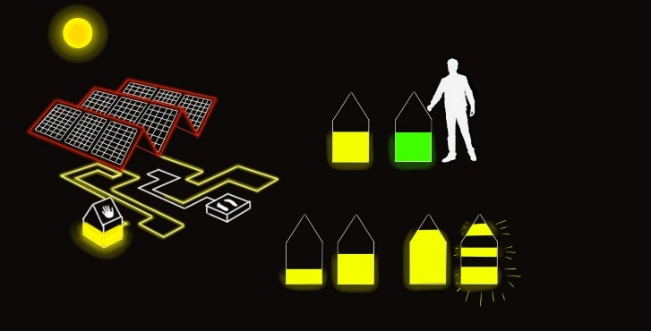**The Grid**

Figure 1 Houses either charge up or are stable during the day depending on usage

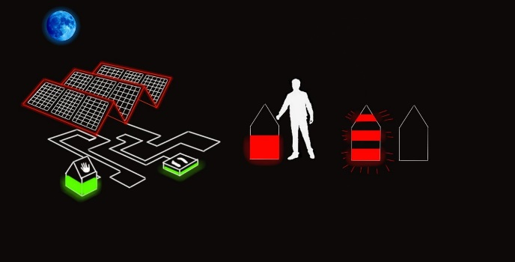Story: The energy grid is inflexible. There is high demand for energy from users during peak hours in the evening. But nowadays there are also a lot of moments where more energy is being generated than the grid can handle. The current power grid is not flexible enough for these high levels of difference in power generation and consumption. The extra power cannot be stored efficiently. These over/under- loads sometimes forces the energy grid to ramp up fossil fuel usage during peak hours, while losing green energy during low hours. Plus, the extreme stress put on the components of the grid makes this a tricky situation and a serious problem.

Figure 2 Houses either deplete or are stable during the night depending on usage

Interaction: During the day, electricity (light) flows from the solar panel to the houses. The houses charge during the day when unoccupied (light level increases), and remain balanced when occupied (level stays the same). At night, no electricity (light) comes from the solar panel, so the houses discharge when occupied (light level decreases). Visitors can stand on 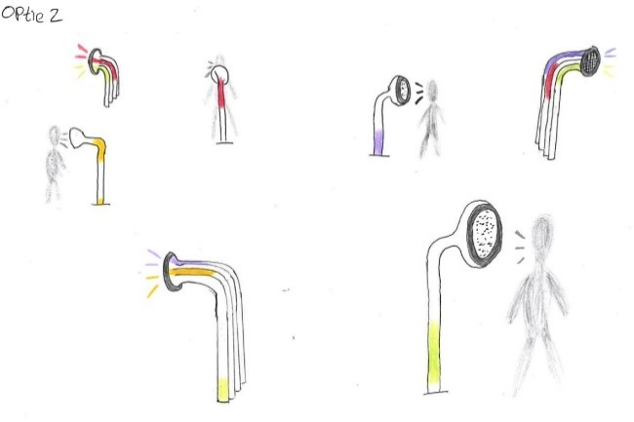"Buildings" or place their hands on the houses to influence the charge rate and SoC.

**Pipes**

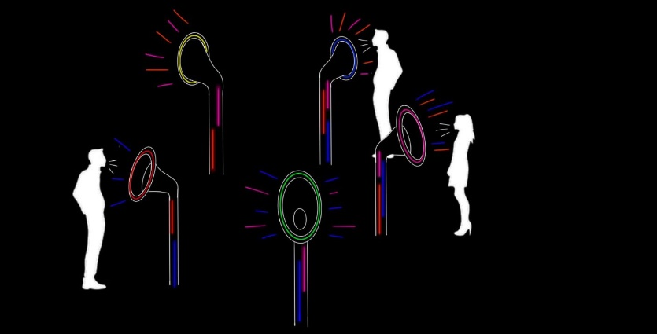Story: To effectively convey a message, silence is essential. However, in online discussions, it's common to see everyone wanting to express their own opinions and messages. This results in many people speaking at the same time and trying to assert their viewpoint without listening to others. As a result, all voices become intertwined, making it impossible to distinguish the various messages. So, someone can shout all you want, but if multiple people speak at once, the initial voice won't be heard clearly.

Figure 3 “Pipes” initial idea sketch

Interaction: It begins with users engaging with a microphone (talking into the horn). Each horn in the installation has a unique colour. Users have the ability to influence the light paths, creating a personalized light/sound experience.

As the sound reach the sensors, they will react to the user's input, guiding light paths through the pipes. There are multiple path options, with the system capable of generating random paths to add an element of unpredictability.

Figure 4 “Pipes” refined idea sketch

The sound ‘travels’ to another horn (all the horns contain both speakers and microphones). This creates a visual representation of the sound, making each interaction unique and engaging.

## A person standing in front of a white board Description automatically generated3.3 Testing & Final Idea

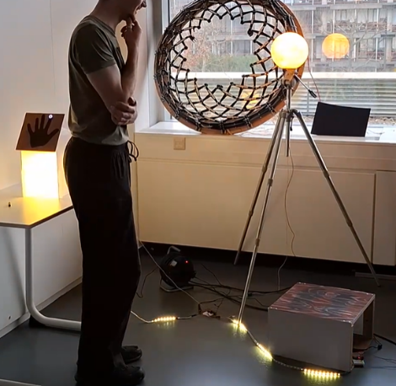Because the team couldn't decide between the concepts, they chose to test both prototypes. During testing, they still found it difficult to choose which concept to eliminate, as both performed well. The Grid primarily underwent testing for its visual appeal. Prototypes of the slab and house were created to see how well the concept conveyed its story, which was generally successful but required some additional explanation.

The Pipes concept was primarily tested to assess the feasibility of transmitting light with sound to another horn, which largely succeeded, although there were issues with certain microphones reacting to ambient noise or not functioning at all. Fortunately, the light transmission aspect functioned properly.

Figure 5 First prototype testing “Pipes”

This demonstrated potential in both concepts, each offering room for improvement. Consequently, the team transferred the final decision to other student teams and representatives of GLOW. During a GLOW academy night, where student teams presented their ideas, the audience was invited to vote for their preferred concept. The Pipes concept received nearly unanimous support from the audience.

Figure 6 First prototype testing "The Grid"

## 3.4 Pipes: 6 concepts

To further develop the concept, 6 different versions of the pipes concept were created. This to get a better understanding of all the different options within the concept

**Concept 1: Network**

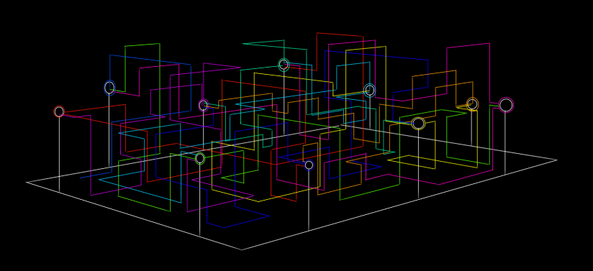This concept features multiple horns arranged in a rectangular formation on a plaza. Each horn is connected to others through a network of horizontal and vertical pipes, all at 90-degree angles. Every horn is linked to at least two other horns, and each horn is uniquely coloured. In the image, for instance, a red horn connects to both a dark blue horn and a turquoise horn. When someone speaks in front of the red horn, a red light beam travels through the network to either the dark blue or the turquoise horn. The receiving horns, dark blue and turquoise, can accept the message but cannot send a reply back to the red horn; they can only communicate through their respective connections.

Figure 7 "Pipes" standalone installation sketch

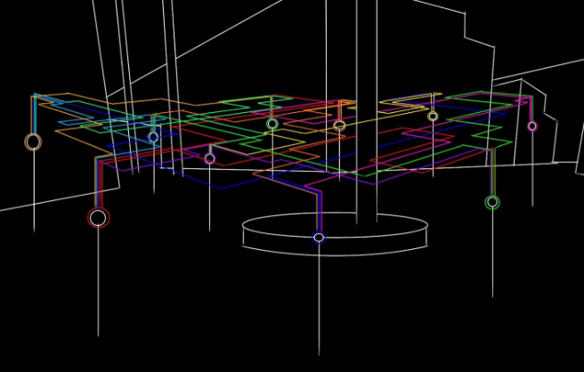**Concept 2: Air Network**

This concept resembles the Network concept but is (almost) two-dimensional. While there are pipes at varying heights, the lowest ones are approximately 2.5 meters above ground, allowing people to walk underneath preserving the walking routes of GLOW. Despite its different structure, the concept operates the same way as the Network concept.

**Concept 3: Spider Web**

Figure 8 Air network, philips museum square overhead

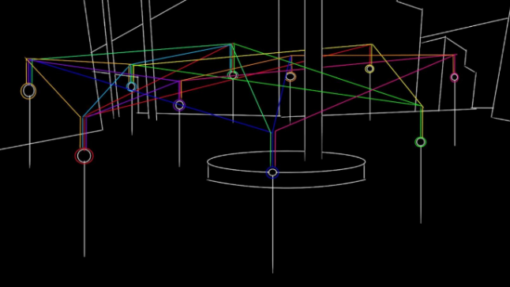This concept follows the same principle as the Air Network concept, with all elements above the people. However, this design features pipes arranged in a spiderweb pattern. Despite the different structure, it functions the same way as the (Air) Network.

**Concept 4: Tree**

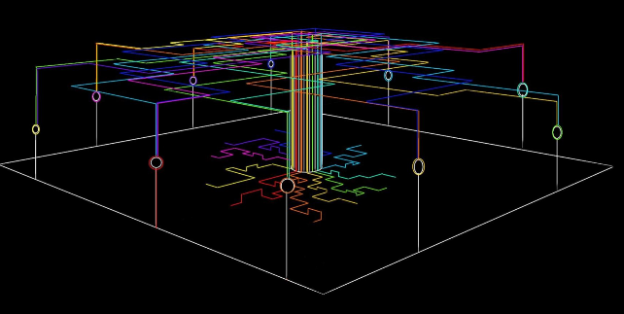This concept features multiple horns interconnected in a tree-like structure. It operates similarly to the network concepts, but here, when someone speaks into, for example, the red horn, the light beam starts at the tree's root, travels upward, and follows the branches to reach, say, the turquoise horn. The pathways represent the tree's branches. This design allows people to walk underneath and around the installation.

Figure 9 Spider web, philips museum square overhead

Figure 10 Tree, standalone installation sketch central point

**Concept 5: Playground**

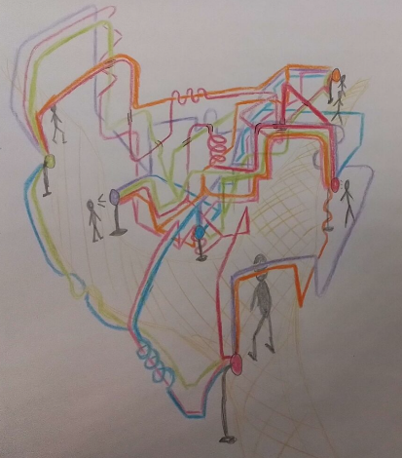This concept consists out of a playground-like structure, combining all kinds of different elements from previous concepts. People can walk underneath the installation and children can crawl underneath it.

Figure 11 Playground, Standalone installation sketch

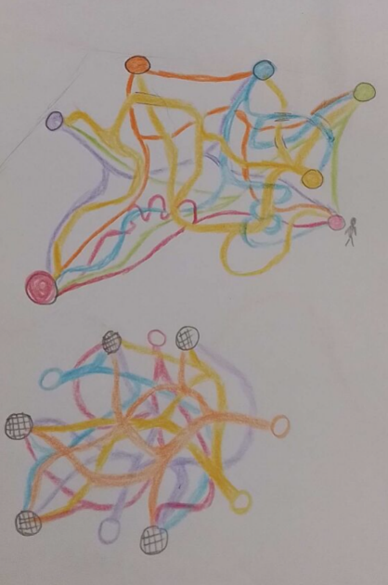

**Concept 6: Mess**

This concept works essentially the same way as the network concepts. It consists out of a network of curved pipes without any corners.

Figure 12 Mess, standalone installation sketch

## A colorful lines and dots Description automatically generated3.5 Final concept (whole installation)

Figure 13 "Pipes" final concept

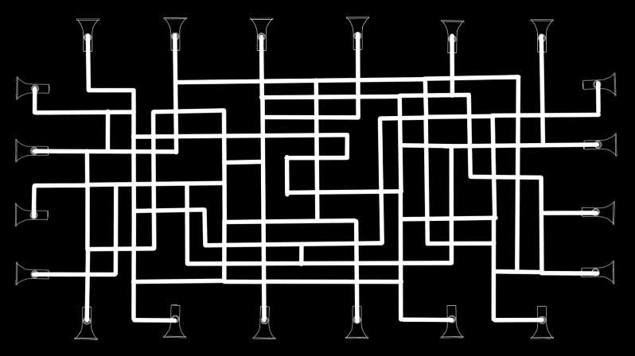After reviewing all the different concepts, a group discussion with the tutor concluded that Concept 1: Network would be the final choice. This decision was based on potential locations, crowd flow, originality, feasibility, and aesthetics. Many other concepts were deemed infeasible or unsafe for GLOW, making this concept the most viable. During the discussion, some minor design changes were made: each horn will have only one pipe leading to the network, rather than multiple pipes. Thus, the network will not consist of direct pipe paths between horns, but rather a single network connecting all the horns (see top view picture).

Figure 14 "Pipes" Top view network

## 3.6 Story

Echoes in Motion serves as a reflection of the digital age's communication dynamics, where streams of voices travel through the vast expanse of the internet, often without the speaker truly comprehending the impact of their words. ​Through Echoes in Motion, users are provided with a visual representation of how their words travel to the recipient. By making the unseen impact of digital interactions visible, Echoes in Motion creates awareness in online communication, encouraging empathy and constructive dialogue. ​

# 4. Construction & Development

## Afbeelding met zwart-wit, licht Automatisch gegenereerde beschrijving4.1 Prototyping

For the prototype a small part of the whole installation was made. It is made on 1:1 scale with 3 horns, and a small network of pipes.

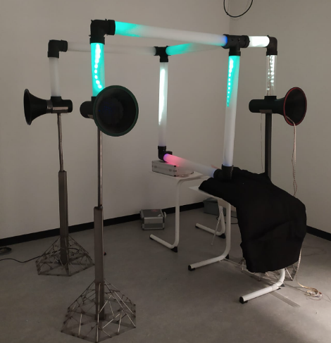It starts with users speaking into a microphone (horn). Each horn features a unique colour, and the small network of tubes defines the potential light paths. Users can influence these paths, creating their own light and sound experience. As sound reaches the sensors, they guide light through the pipes with multiple path options. Sound travels to another horn, with the light path length dynamically changing based on the user's speech duration, visually representing the sound and making each interaction unique and engaging. The inner tube is used to guide the LED strips and to pass the cables from one section to the next.

Figure 15 Solidworks prototype

The prototype has fewer components and therefore fewer possible paths through which the voice and light can travel. But the three horns show that the message can be received at any one of them, so the effect of not knowing where the message is received is still there.

## 4.2 Final Installation

The final installation is a design where there will be tubes that vary in length and height that create a complicated web of options for a voice to travel through. How it overall works is described in chapter 3.5. And the precise software, electrical and mechanical design are described in the rest of the chapter. There are also horns with varied heights so it is accessible to all ages and people in wheelchairs. The different heights are 160 cm, 120 cm and 90 cm. The size of the installation is 2,1m (height) x 6m (width) x 8m (length).

Figure 16 Build prototype

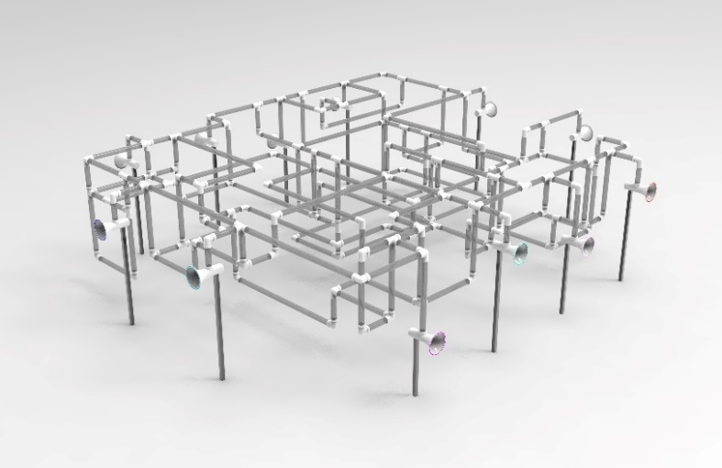

Figure 17 Solidworks final installation

## 4.3 Mechanical Design

**Pipes**

Two distinct types of pipes are in use: an inner tube and an outer tube. The inner tube is transparent with a diameter of 50 mm and serves to hold the cables and the LED strip. It is transparent, allowing the light emitted by the LED strip to pass through to the outside, where it is somewhat diffused. The inner pipe is centred within the outer pipe. The outer pipe is satin with a diameter of 80 mm. The satin nature of the outer pipe diffuses the light emitted by the LED strip, preventing the user from seeing the LEDs on the inside. This diffusion also ensures that the tube emits an equal amount of light brightness on all sides.

The pipes used in the prototype are identical in measurement to those for the entire installation, ensuring they can be used interchangeably in the future as well. The different measurements are:

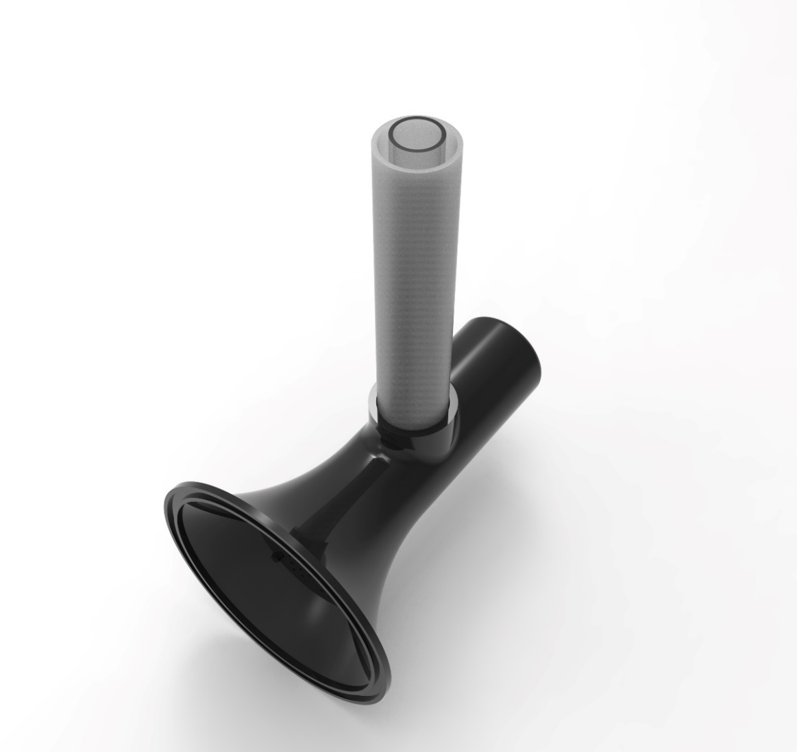

Inner tube (outside diameter 50mm, wall thickness 3mm):

* Short tube: length 400 mm
* Middle tube: length 940 mm
* Long tube: length 2020 mm
* Tube used for the 160 cm high horn: 320 mm
* Tube used for the 120 cm high horn: 720 mm
* Tube used for the 90 cm high horn: 1020 mm

Outer tube (outside diameter 80mm, wall thickness 3mm):

* Short tube: length 380 mm
* Middle tube: length 920 mm
* Long tube: length 2000 mm
* Tube used for the 160 cm high horn: 300 mm
* Tube used for the 120 cm high horn: 700 mm
* Tube used for the 90 cm high horn: 1000 mm

Figure 18 Inner and outer pipes

The pipes in the current prototype are from acrylate. This material has been chosen because of its affordability compared to the other options and was still in stock at the distributor. But this material is very brittle when compared to other materials. In the recommendations another material is suggested.

**Horn**

The horn is a 3D-printed component secured by a pole and designed to be safe for users. It serves as both the start and end point of the tubes. It houses the speakers, microphones, power supply, and ESPs. A front separation plate with holes allows sound to pass through while preventing access to the internal components. For detailed drafts, refer to Appendix A5. To prevent rainwater from seeping into the horn, a 2mm groove at the connection point holds a rubber O-ring, effectively blocking water entry and preventing short circuits.

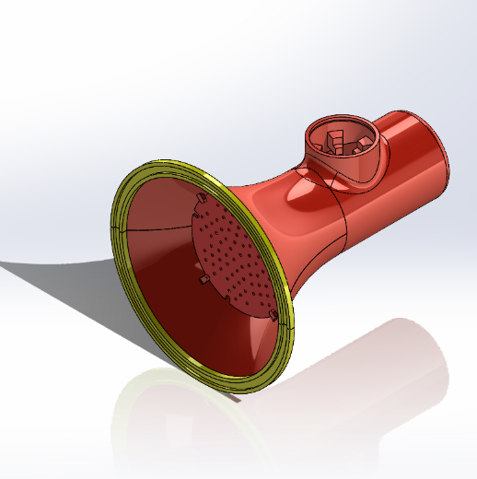

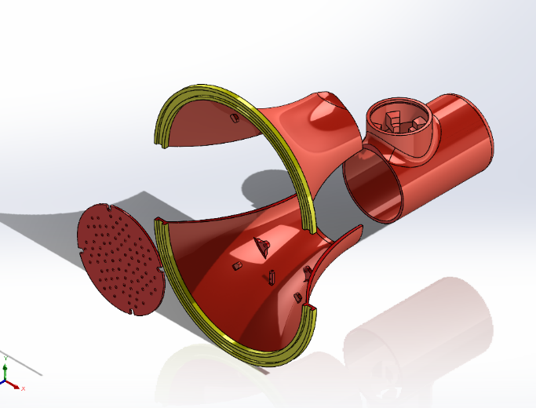

Figure Solidworks horn exploded model

Figure Solidworks horn model

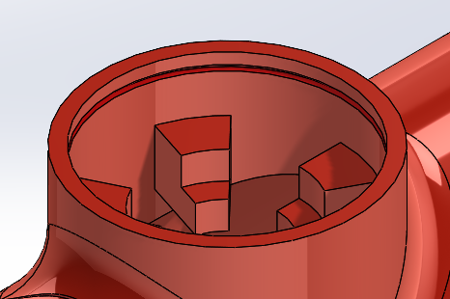

Figure 21 Solidworks horn pipe connection with O ring

**Cross-section**

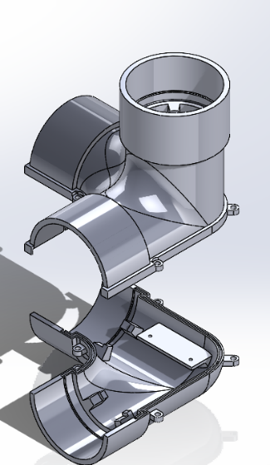The cross-sections are the intersections between multiple directions of pipes. All the cross sections can be seen in appendix B1 till B4. The cross sections are designed to house all the necessary electronics and will hold the inner and outer tube in its place. There is also a place where the PCB can be attached with 2 M2 bolts. The bottom and the top of the cross sections are separated so they are easily accessible for making adjustments and setting up the PCB, the LED’s and the cables.

Figure 22 Cross-section XYZ

There are some cross sections who also serve as support. These cross-sections will be connected to a pole, through the pole the power supply can be connected. These poles need to be sturdy to withstand the static forces of the installation itself and the dynamic forces of the wind. In total there are 3 different cross sections in the prototype, and 4 different ones in the entire installation.

To stop rainwater seeping into the cross-section, there are grooves at the top and bottom that are 2mm deep. These are connected to grooves in a circular form. Rubber O-rings and rubber strips are placed in these grooves to block rainwater. On the top parts of the cross-sections are ridges that overlap the bottom part. This is crucial to prevent water from coming in.

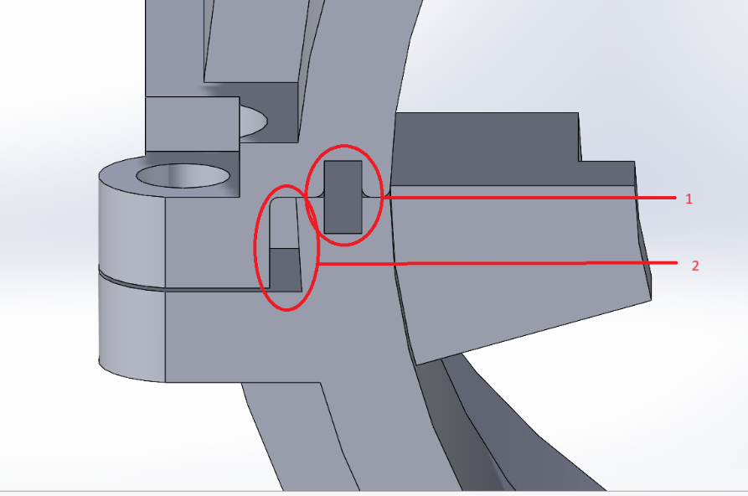

Figure 23 Section view of the cross-section with water resistance 1. Placement of the rubber strip 2. Ledge hanging over the bottom part of the cross section

**Waterproof**

The installation will be outside during November, which means that there is a high risk of heavy rain fall. Both the horns and the cross sections are made with a 3D-printer. There are different options to make the prints waterproof.

Resin printer, in the resin printer, the layers are lasered into a liquid bath. This leaves no pores between the different layers that make up the product. MJF, SLS, SLM and SLA 3D printers are like the resin printer with no pores between the layers, this print is waterproof to a pressure of at least 7 bar, where the print is completely submerged.

FDM 3D printers print in cylindrical layers stacked on and next to each other, this creates pores that allow water to seep in through the walls. To counteract this, sealant AM Hydro #2589 can be used, it seals all the pores of the print. It works by immersing the part in it for 10 min and then letting it evaporate.

## 4.4 Electrical design

To get the light and interactive parts working in the installation, some electronics are required. These electronics include the audio system, the light system and an overarching control system. The audio system can further be broken down into the microphone system and the speaker system.

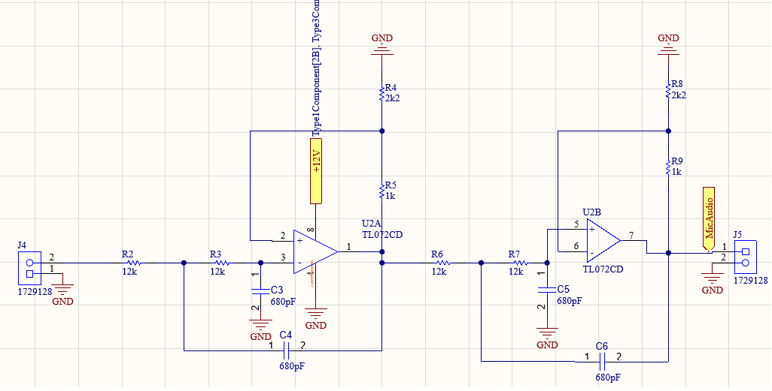**Microphone system**

The design of this system started before the specific microphone was selected. Because of this, a second order lowpass filter with a cut-off frequency of 20 kHz was implemented. This cut-off frequency was chosen since most full range speakers, and human hearing, go to about 20-22 kHz. This enables the horns to use bare microphones which do not have any supplementary circuits. For the prototyping stage, an all-inclusive microphone was selected which could directly be connected to the speakers without interference. To detect whether a person is talking into a horn a sound sensor was selected. When a certain noise level is reached, it will send out a digital signal alerting the controller that someone is speaking into the horn. Even though the circuit Figure shows the line from R7 going into the positive side of the OpAmp, this was to compensate for the footprint not being correct.

Figure Microphone circuit

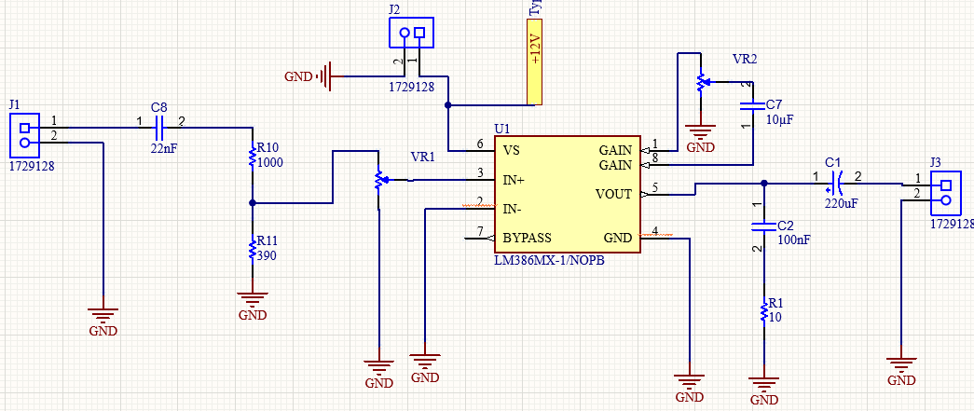**Speaker system**

For the speakers, the Visaton FR 10 HMP was chosen because the size would fit well in the front horn design, the power output is 20-30 Watt and it has an IP64 rating which should help with the waterproofing of the system. To drive the speakers, the LM386 was selected. This chip, with a corresponding circuit, is able to drive speakers between 0.5 and 50 W, where the 20-30 FR 10 HMP falls nicely in the middle. Another attractive side of the LM386 is that with the addition of two potentiometers, the volume and the gain of the speaker can also be adjusted.

Figure Speaker circuit

**Light system**

A major part of GLOW is the light in the installation. For the message Echoes in Motion wants to send, multi-coloured light is required to show from which horn the message is coming. This immediately narrows down the possible options to just RGB LEDs. However, even for “just” RGB LEDs there are still a few options left, namely: RGB, RGBW, RGBWW and Neon flex. For the purpose of the system, having a dedicated white light has no added value so the choice is between neon flex and RGB. Since neon flex is 2-3 times more expensive for, in this case, little added value, it was decided upon to use RGB LEDs. Taking price and performance into account specifically the 60 LEDs/m RGB LED strips. These LED strips use 12V and take about 15W per meter. This is the biggest energy consumer in the system, seeing that about 160M of LED will be used. The LEDs account for 2400W out of the less than 3000W which the system will use.

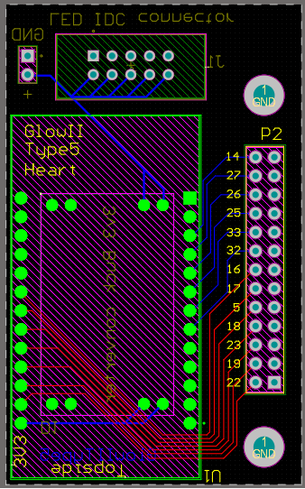**Control system**

There are two things to control in the installation: audio and light. For the prototype the focus has been on the light segment. The light will find its way from horn to horn in an automatic way. This is done by having a controller in every junction which will tell the next RGB strip to move, in which colour and when. This is all done in software, so the electrical only has the provide the GPIO connection to allow the RGB strips to communicate with the ESP32. These junction pieces also include 12V connections to power the LEDs, the board itself or the entire chain by adding another power supply to it. This PCB can be seen in Figure

Figure Junction controller PCB

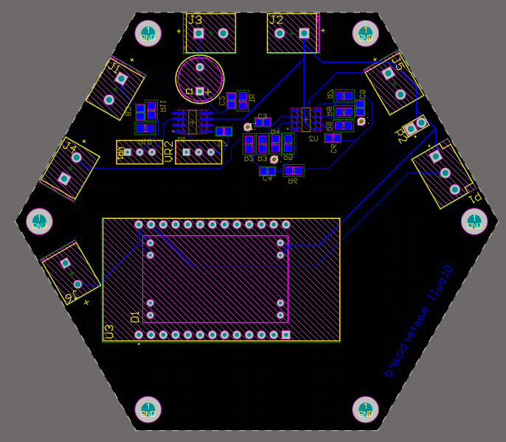**Horn control system**

Most of these systems were integrated into the horn board, except for the Junction controller PCB. This integration allows the horn to have a singular PCB with which all components can be connected as seen in Figure .

Figure Horn PCB

## 4.5 Software

For more in-depth explanation, look into the accompanying software documentation.

**Requirements:**The system consists out of a network of pipes. When a horn gets spoken into, it will send the voice though the network to another connected horn in the form of a light pulse. When the light pulse has arrived at its destination, the voice will be played at that horn.

The system consists of many pipe modules connected to each other with junction pieces. All modules communicate with each other to coordinate light and sound. The final system will be modular, meaning that the specific setup can be changed and components can be replaced at any time. Next to these modules in the installation, there will be a master module outside of the system.

**Module functions**The system consists of many junction pieces with which you can make a lot of system configurations. This allows the builders to make the system in any shape they want. It also allows for ease of maintenance, being able to swap a defective piece without any major changes. To allow the modules to do this, they all know their own shape. This is the only difference in code between all modules in the whole system. To allow for modularity, the junctions are able to discover their neighbours on their own.

**Self-Discovery**The system consists of many modules, all connected to each other in a big network. In order to manage this network, a master is present. Modules will communicate to their neighbours via the “Comms line”. They will then inform each other who they are. This information will then get send to the master. This master will create a 2D map of all connected modules with this information.

**Communication & Wiring**To achieve communication, every horn has a “Comms” wire running through the pipes in all directions to communicate with their neighbours. See Figure 28” This wire(green) can be seen coming from one module going to another. The controllers are connected via the GND & 12V lines from the LED strips. Aside from the LED strips delivering power, there will also be a wire for synchronising led timings. This wire is not the digital LED driving signal, since this data is not shared between modules).

This network relies on serial data pass through. Every module functions as a repeater, repeating all of the transmissions it receives. When a module transmits a signal, it will be received by its neighbours on the “comms” wire. This neighbour will then in turn retransmit this message to its own neighbours. This repeats as the message travels through the network until it reaches its destination.

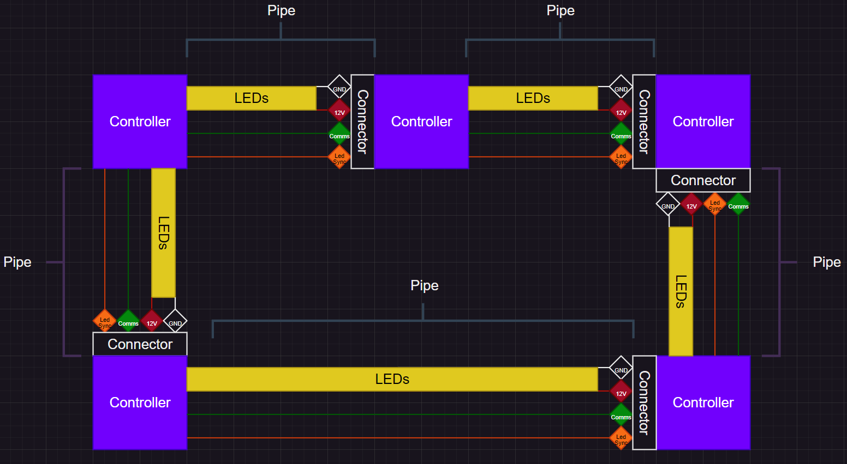

Figure 28 System Functional Diagram

**Pathing & Lighting**When a horn detects that someone is talking into it, it will inform the master. The master will run a pathfinding algorithm to route a path through the 2D map. This path data is then analysed for all the modules it has to travel through. When this is done, it will transmit the instructions to all the modules containing LED effects. Once all these transmissions have been sent, it will send out a pulse on the “Led Sync” pin. All modules will receive the signal at the same time and will start playing the received LED effects, but because the transmissions contained delay offsets relative to their position in the path, it will look as if the light is travelling through the pipes.

**Updates**All modules in the system are equipped with OTA update capabilities. This adds the ability to update system software wirelessly; without having to connect every single individual module with an USB cable to a laptop.

# 5. Promotion & Sponsoring

## 5.1 Website

To share the design with a larger audience the project team has started to build a website. With this website the sponsors and other interested parties can follow the build. The building of the website is still in progress.

## 5.2 Sponsorships

Manufacturing the installation requires funding. Every year, this funding comes from Fontys Engineering itself and multiple external sponsors. These external sponsors usually provide funding, material or expertise. This year, Mark Herman has been approached. He is in charge for everything sponsoring related at Fontys. This sponsor acquisition process has been started, but as of writing no sponsors have been found yet.

# 6. Future & Financing

## 6.1 Preparation Future

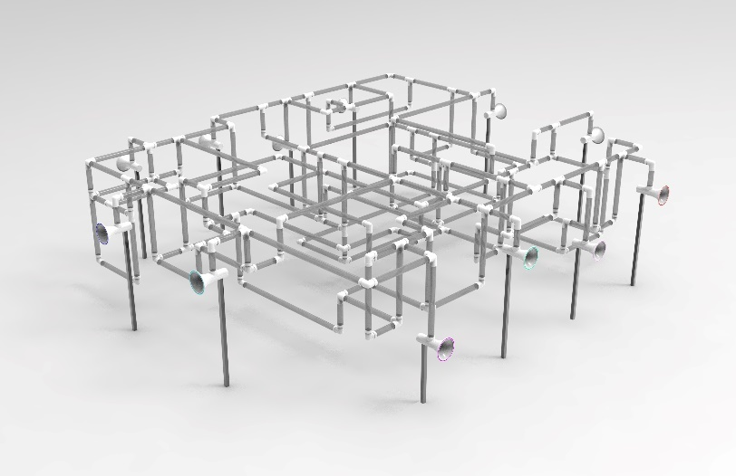**Mechanical**

Figure Solidworks final installation

The design for the entire installation has already been completed and can be utilized for the second part of the project. All cost calculations are based on this design, so it is recommended to adhere to it. The designs for the cross sections and horns can also be applied across the entire installation. Additionally, certain components, such as a few meters of pipe, have already been ordered.

**Software**The codebase has been developed with the goal of being the production implementation. However, there are a few catches to this:

* The shown prototype has Wi-Fi communications instead of the serial pass-through system described in chapter 4.5.
* While idle effects functioned, light effects from module to module did not work. To compensate for this, a LED strip was manually pulled through the prototype system to emulate what it would look like to see the travelling effect.
* The system is currently only capable of mapping a 2D grid, not 3D.
* The codebase itself is not finished. See chapter 7.2 for more detailed recommendations.

All code is stored on GitHub:  
Codebase used for developing the prototype which was built is stored on “Semester-1-Prototype”  
The production codebase is stored on Main. This codebase is not complete and will need work to get it to a functional state.

## 6.2 Financing

An initial estimate based on window prices puts the cost of the entire installation at about 13 thousand euros, the biggest components being the pipes and the LED strips. This price is expected to drop a bit when approaching vendors for bulk purchase, but until quotation is made it is unknown by how much.

A detailed breakdown of required components and funding can be found in the appendix

# 7. Conclusion & Recommendations

## 7.1 Conclusion

The report details the process of designing and developing the "Echoes in Motion" installation for the GLOW Festival. It highlights the importance of innovation, collaboration, and technical skills in creating an interactive light art installation.

## 7.2 Recommendations

**Mechanical**

For the mechanical part of the installation a number of things could be recommended for the future:

* The pipes could be of a different type of material, this to ensure that the pipes would not break while building up the prototype.
* It is recommended to find a better way for the LEDs to be equally distributed on the inner transparent pipes. Now the LEDs can be seen from the outside.
* In the prototype, satin and transparent acrylate pipes are used. For the entire installation it is recommended that a different material is used (still with the same aesthetics). Polycarbonate pipes could be an option.
* The design of the cross sections could be changed so the electrical parts could be more easily accessed.
* Waterproofing of the horns and cross sections is something that also needs to be improved.
* The cross sections could be purchased, with custom inserts 3D printed for the pipes. This would save significant time, though it may increase costs.
* For the final installation, it is recommended to have an engineer conduct a static force analysis, including considerations for wind speeds up to 8. This to make sure that the installation would hold in November weather and that it is vandal proof.
* A better method for attaching the standard to the horn should be investigated.
* If the entire installation is waterproof and airtight, the heat emitted by the LEDs needs proper ventilation. It is advisable to investigate: How much heat do the LEDs generate? Could this heat damage them? How can the installation be enhanced to eliminate potential risks?
* For the entire installation, it is still necessary to determine the extent and locations where additional support in the form of extra standards is needed to support the pipes and cross sections.

**Audio**

For the audio switching it is advised to either make or purchase a DSP. A 12 channel IO DSP is expensive, so if this cannot be acquired from a sponsor, the recommendation is to make a DSP like the ones available at freedsp.github.io.

**Software**These are some ideas & components which could not be implemented in time.

* The modules should have a wired communication instead of Wi-Fi.
* The current wired communications are not functional.
* Double retransmission prevention: Right now, there is no system that checks if a message was already received before. This means messages will be infinitely retransmitted and will break the network by flooding it with transmissions.
* Audio Triggering: No proper method of triggering a horn with sound has been implemented. The initial solution was to use a sound sensor which triggers at a certain level and sends out a digital signal to the controller so that the master can control the light and sound coming out of the destination at the same time.
* Fix the pathfinding algorithm since it is not complete yet.
* Module self-discovery on UP/DOWN(Z)-axis not implemented. Current code is only available in 2D form or in a flattened 3D style.
  + Solution 1: Implement a system with a list of pre-defined positions for modules to be in. This bypasses self-discovery, preventing new complex code having to be designed. This solution does however take the modular out of modular system, only leaving the advantage of quick replacement.
  + Solution 2: Fake 3D by making multiple 2D planes next to each other. This prevents modules having the same X and Y coordinates when they are on top of each other.
  + Solution 3: Figure out a way to make a 3D array work with this system, being able to provide an X, Y and Z coordinate to every module.

# References

Eindhovens dagblad. (2011, oktober 27). *GLOW 2011: welke projecten sieren Eindhoven dit jaar?* Opgehaald van ED: https://www.ed.nl/glow/glow-2011-welke-projecten-sieren-eindhoven-dit-jaar~adc82602/#:~:text=Het%20thema%20luidt%20dit%20jaar,van%20de%20offici%C3%ABle%20Glow%2Dwebsite.&text=Vorig%20jaar%20was%20de%20Demer,plein%20voor%20het%20NS%2Dstation

Glow. (2024, juni 19). *Glow Eindhoven*. Opgehaald van https://gloweindhoven.nl/en/

Glow, O. o. (2024). Glow academy night.

NOS nieuws. (2016, november 12). *Eindhoven straalt tijdens elfde lichtfestival Glow*. Opgehaald van NOS: https://nos.nl/artikel/2142816-eindhoven-straalt-tijdens-elfde-lichtfestival-glow

Wijs, M. S. (2018, december 2). *GLOW: Made in Eindhoven*. Opgehaald van MM nieuws: https://www.mmnieuws.nl/article/glow-made-eindhoven-lichtfestivals-schieten-als-paddenstoelen-grond/

# Appendixes

## Appendix A SRD



Echoes in motion

System Requirements Document



5 April 2024

Fontys Engineering

De Rondom 1, Eindhoven

**Name of the group:** <GLOW II>  
**Name of the group members:** **<**Ask Blommaert, Sophie Homan, Tim Kuiper, Daniël van Langeveld, Jolien Renette **>**  
Document ID: SRD_GLOW_II.docx .

|  |  |  |  |
| --- | --- | --- | --- |
| **Release** | **Date** | **Author** | **Main changes** |
| R01 | 05/04/2024 | DLD, TKR | Document Setup |
| R02 |  |  |  |
| R03 |  |  |  |

Introduction 6

1. Background 7

1.1 GLOW festival 7

1.2 Fontys BeCreative 7

2. Problem analysis 8

2.1 Problem description 8

2.2 Research goal 8

2.3 Conditions & restrictions 8

2.4 Approach 9

2.5 Requirements 9

3. Concepts & Story 10

3.1 Brainstorming & Fontys BeCreative method 10

3.2 Concepts 10

3.3 Testing & Final Idea 11

3.4 Pipes: 6 concepts 12

3.5 Final concept (whole installation) 13

3.6 Story 13

4. Construction & Development 14

4.1 Prototyping 14

4.2 Final Installation 14

4.3 Mechanical Design 15

4.4 Electrical design 17

4.5 Software 20

5. Promotion & Sponsoring 22

5.1 Website 22

5.2 Sponsorships 22

6. Future & Financing 23

6.1 Preparation Future 23

6.2 Financing 23

7. Conclusion & Recommendations 24

7.1 Conclusion 24

7.2 Recommendations 24

References 26

Appendixes 27

Appendix A SRD 27

Appendix B Mechanical Design Components 34

Appendix C Electrical circuits and PCB designs 39

Appendix D BOM & costs 41

Appendix E Task division 43

**Content**

**List of tables**

Table 1 Client requirements 31

Table 2 Functional requirements 32

Table 3 Non-functional requirements 33

Table 4 Constraints 33

Table 5 Reference document 33

1. Purpose of the SRD document

This document is made with the intent to make the requirements of the GLOW project for team 2 concrete and easily accessible. This document will contain both the requirements given by the client (GLOW organization) and the requirements made by the GLOW II project team based specifically on the design. This document will also form the basis for the test plan which will determine whether the project was a success. Certain parts of the test plan cannot be tested until the final version of the installation has been made.

2. Introduction

GLOW is a light festival in Eindhoven which is held annually in November. Fontys usually provides at least one team to make an installation for this festival. During the spring semester, a GLOW team will work on the idea, make the design and initial prototype and during the fall semester a GLOW team will scale up the design the spring semester made. These two teams are usually made up of different people, which stresses the importance of documentation. This document is made by the Spring semester GLOW team II. The GLOW organization expects a fun or beautiful interactive light exhibit, centred around a central theme which changes every year.

3. Main domain concepts

3.1 Concept

The theme of this year is “The Stream”. Using the Fontys BeCreative GLOW method, a 100 ideas were gathered (20 per person), and from these concepts the final concept was chosen. The final choice was between two concepts and by popular vote at the GLOW academy the final concept to be worked out was decided. This concept uses light to showcase the movement of sound from one transceiver(henceforth pole) to another. The poles will be connected in a network, where the light will showcase the path of the sound. This installation can be made in a modular way, where it can be scaled up or down depending on budget and available space.

3.2 Unit price and budget

The initial budget is about €3000, of which €300 has been set aside for the prototyping phase. The target material price is thus below €300 per unit. The installation will be modular so that the total amount of poles will mostly be dependent on the budget, but the current preference is about 15-20 poles in the final installation. When the first pole and its corresponding connections have been figured out, the unit price will likely be lower than €300.

3.3 Potential target groups

The visitors of the GLOW event are the target audience of the installation. The visitors can vary wildly in type of people and their interest. The main groups will be children, couples, families and art enthusiasts.

The first group that is going to watch and interact with the exhibit are children, children can be very enthusiastic loud and can turn almost anything into a playground. They have short concentration spans and can get bored easily if it’s not stimulating enough. The intention is that the exhibit is easily to understand, have the freedom to run underneath our sometimes over the installation and will be fun to speak messages into the pole.

The second group of possible visitors is the couples. These people try to enjoy the GLOW festival with their significant other. They should be most interested in either the aesthetics of the installation which both can enjoy or something interactive they can do together.

Another group which usually visits the glow festival is families, most likely a combination between grandparents, parents and children. This is a diverse group with varying interests, but if children are present, they are most likely the focus of this group. These children were already covered in a previous section, so the focus now is the parents and grandparents. These people are more likely to want to enjoy the exhibit from a distance, soaking in the looks of the attraction and appreciating the technology behind the installation. If children are present, they will want to do something together with the kids.

Last but not least, the art enthusiasts. This group of people will have more experience with art and tries to enjoy the aesthetic aspect of the design. These people are also more likely to try to understand the message behind the exhibit. These people are more likely to enjoy the piece of art from a distance to see the full picture instead of going close to experience the interactive part of the installation.

4. **User requirements (client)**

The GLOW organization has provided all participating student teams with the requirements shown in Table 1:

|  |  |  |
| --- | --- | --- |
| ID | Client Requirement | MoSCoW |
| CR1 | The art exhibit must not cause any harm to any of the visitors of the Glow festival. (Safe) | Must |
| CR2 | The installation must be aesthetically pleasing to the visitors of the glow festival. | Must |
| CR3 | The art exhibit must be able to survive outdoors for at least a week while tormented by November weather. | Must |
| CR4 | The art exhibit should be compliant with the Glow Theme, which is “The Stream” in 2024. | Should |
| CR5 | The Glow project should stay within budget. This budget can be increased by seeking out sponsors. | Should |
| CR6 | Visitors of the Glow festival should be able to interact with the art installation. The installation should be able to react to these interactions. | Should |
| CR7 | The installation could be transportable to be shipped to other light festivals. | Could |

Table 1 Client requirements

5. Functional requirements

Table 2 below shows the requirements of what the exhibit should be functionally capable of doing.

|  |  |  |  |  |
| --- | --- | --- | --- | --- |
| ID | Requirement | Source | Rationale | MoSCoW |
| F1 | The light used must be RGB | Team | To be able to get the required colours(10+) for the installation to come to its full potential, there needs to be RGB | Must |
| F2 | The horns must have working speakers and microphone | Team | A central theme of the installation is that the sound is recorded and played again in another place | Must |
| F3 | The installation must react to the activation of the microphone | Team | The entire concept of the installation is based on the fact that the flow of sound is visualized with light. If the light does not move together with the sound, it falls apart | Must |
| F4 | The system must show the travel path of the sound using light | Team | This is the entire basis of the system | Must |
| F5 | The playing of the sound should be delayed until the light has arrived | Team | If the light is delayed it is more visible where the origin of the sound came from | Should |

Table 2 Functional requirements

6. Non-functional requirements (quality requirements, properties)

The properties which the art installation should exhibit are listed in Table 3 below.

|  |  |  |  |  |
| --- | --- | --- | --- | --- |
| ID | Requirement | Source | Rationale | MoSCoW |
| NF1 | The project needs function daily for at least a week. | Glow | For the duration of the Glow festival (one week), the installation must function during opening hours (4.5 hours a day, 18:30 to 23:00) | Must. |
| NF2 | The project needs to be weather resistant in November (water/snow/wind) | Glow | The art installation needs to be shown in November and the weather can be very different | Must |
| NF3 | The installation must not have any exposed wiring | Team | To ensure safety and robustness in outdoor conditions it is ill-advised to have any exposed wire connections | Must |
| NF4 | There must not by any sharp edges on the installation | Team | Because of safety considerations, it’s advised that there are no sharp edges with which a person can cut or harm themselves | Must |
| NF5 | The entire installation should be powered by a single 230v, 16A power connection | Team | A power connection will be provided by glow. For ease of use it is better if it can be powered by a single circuit breaker, which usually has a limit of 16A | Should |
| NF6 | (Overhead only) Overhead connections should be at a minimum height of 2.5m | Team | To ensure ease of passage it is better if the connections are not in the way of people’s heads | Should |
| NF7 | (on-the-ground only) Connections on the ground needs to be sturdy enough that someone can walk on top of it | Team | People can accidently step on the connection, so for safety reasons it needs to hold the weight of heavy adult | Should |
| NF8 | (Enterable only) Installation should be wheelchair accessible | Team | It is most fun if everyone can enjoy the art installation, also those people who are not as mobile as others and require the help of a wheelchair | Should |
| NF9 | The installation should be sturdy enough to handle inquisitive kids and slightly belligerent students (specifics dependent on design) | Team | The model is outside and can be interacted with. If it is within touching range, some people are going to try out what the installation can handle | Should |
| NF10 | The dismantled installation could fit into a standard size shipping container. | Tutor | The installation might need to be shipped to another light festival, shipping container is the easiest mode of shipping. | Could |

Table 3 Non-functional requirements

7. Constraints

Like all projects, there are some constraints which might impact the success of the project. Mitigation plans are in place to reduce their impact.

|  |  |  |  |
| --- | --- | --- | --- |
| ID | Constraint | Rationale | Mitigation |
| C1 | Time | There are multiple deadlines which should not be breached. The crew working on the project next semester only has limited time to upscale the project to the final iteration. | Keeping on top of the progress of the project, making sure no deadlines are breached so that the next team can get right into upscaling |
| C2 | Budget | Fontys Engineering has only budgeted a specific amount of money at the start of the year, in the case of this year about €3000. | Find sponsors and do some “creative accounting”(other option: Strategically Transfer Equipment to Alternate Locations) |
| C3 | Material and tools | Fontys Engineering Eindhoven (Nexus) has limited resources in some aspects. Components and machines might not be freely available during the prototyping phase. | Visit other Fontys locations which might have tools and materials required during the prototyping phase. |

Table 4 Constraints

8. References

The document(s) in Table 5 have been used in the creation of the requirements of the SRD.

|  |  |
| --- | --- |
| Name of the document | Short description of the document contents |
| BeCreative Project Proposal - Glow 2022.pdf | This document contains user requirements |
|  |  |

Table 5 Reference document

## Appendix B Mechanical Design Components

B 1 2 cross section angle, water resistance

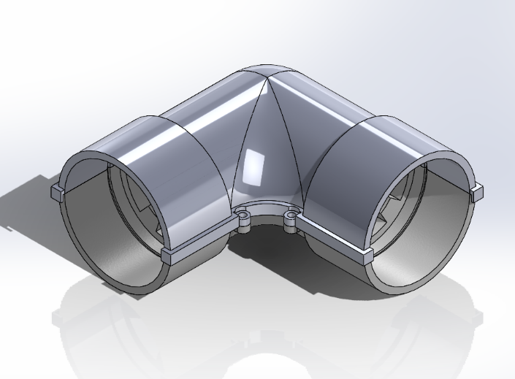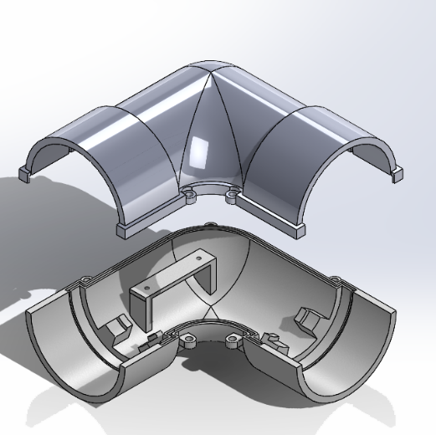

B 1.1 2 cross section angle bottom

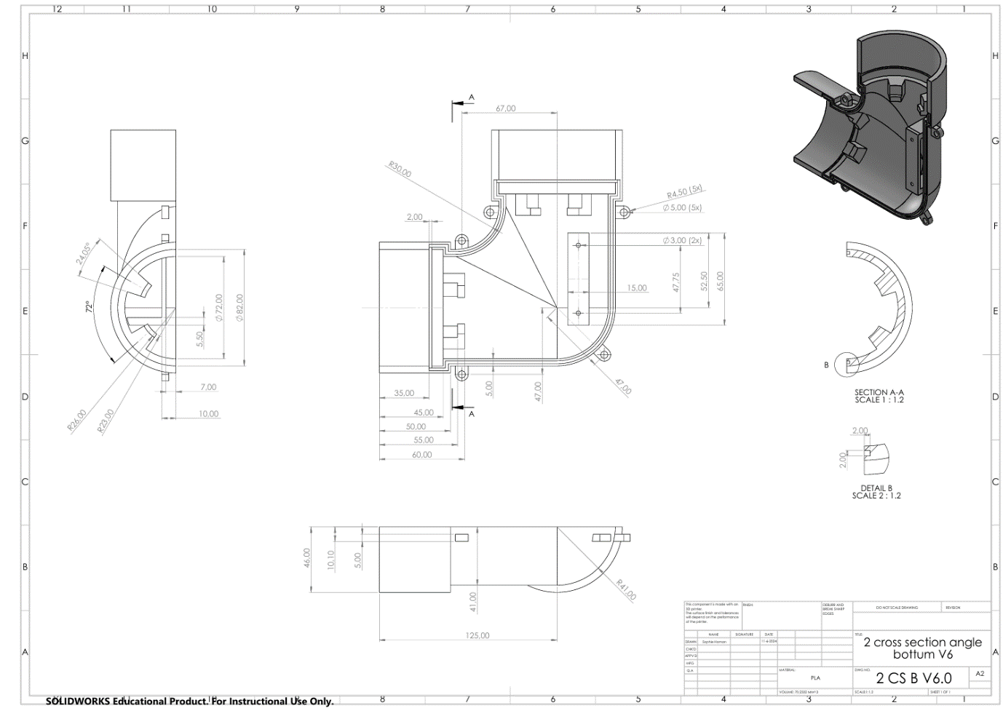

B 1.2 2 cross section angle top

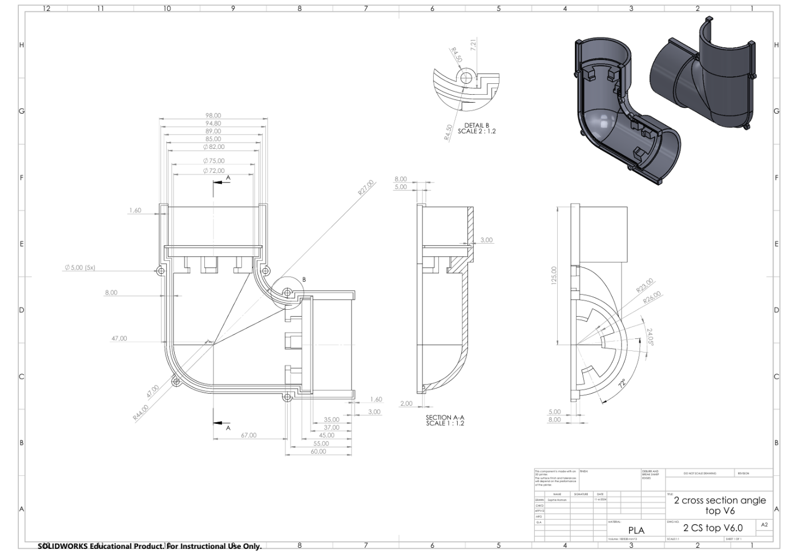

B2 4 cross section T 1up, water resistance

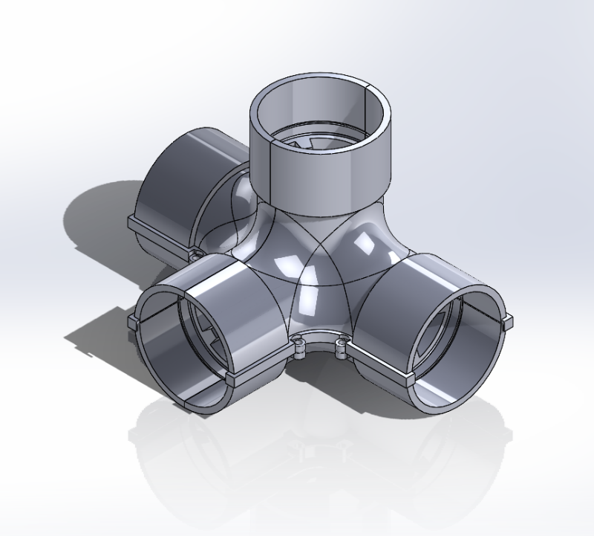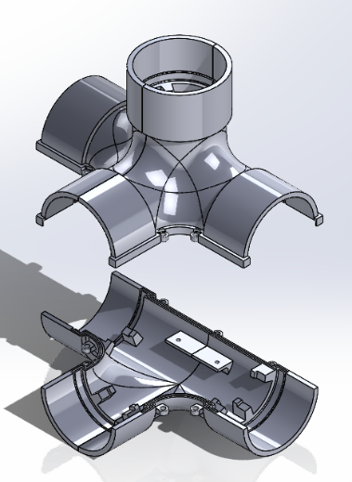

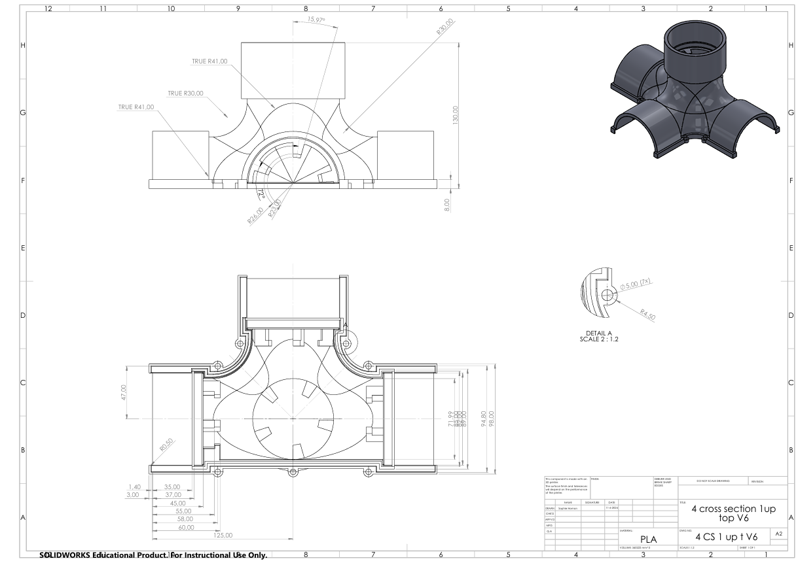

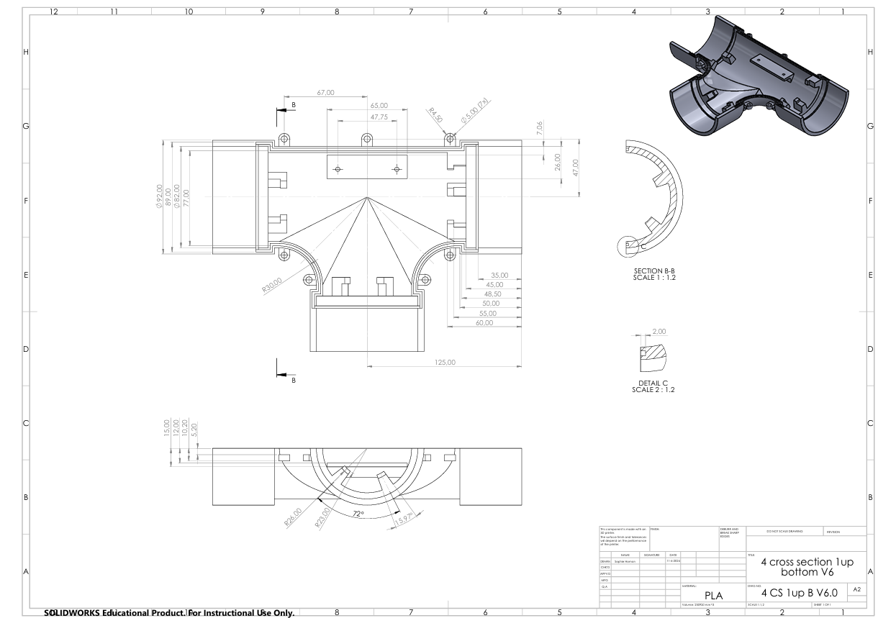

B3 3 cross section xyz, water resistance

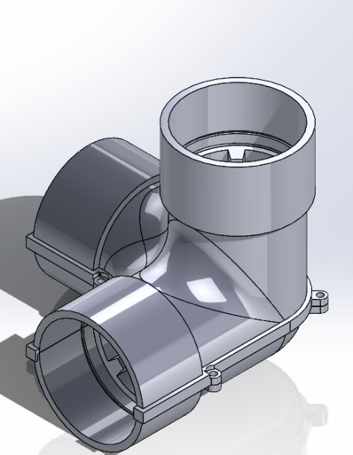

B4 3 cross section T, water resistance

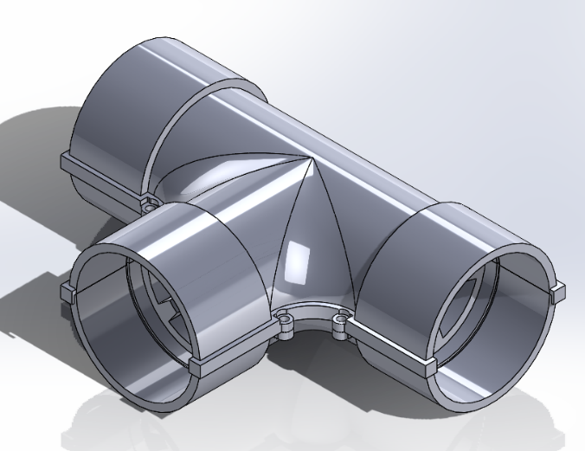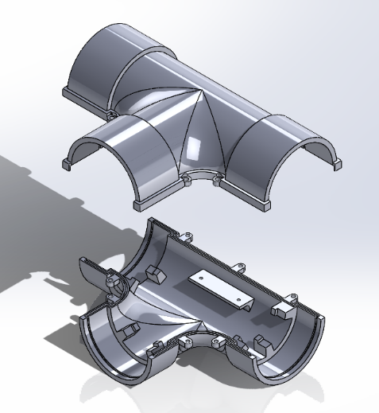

B5 Horn, water resistance

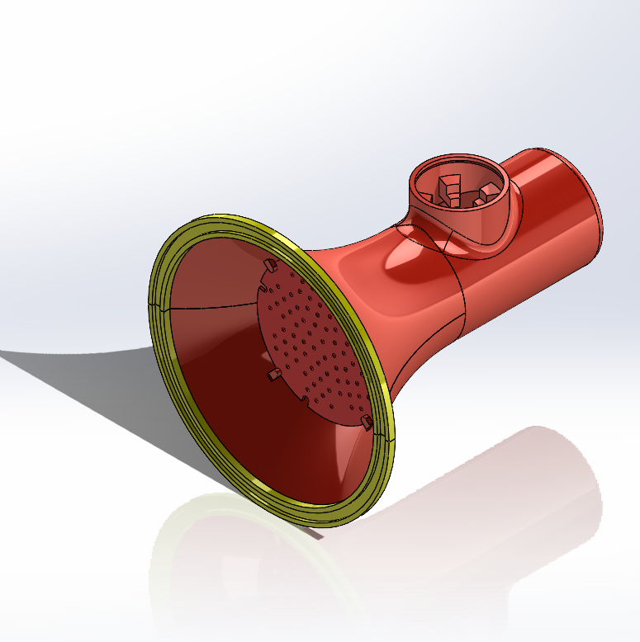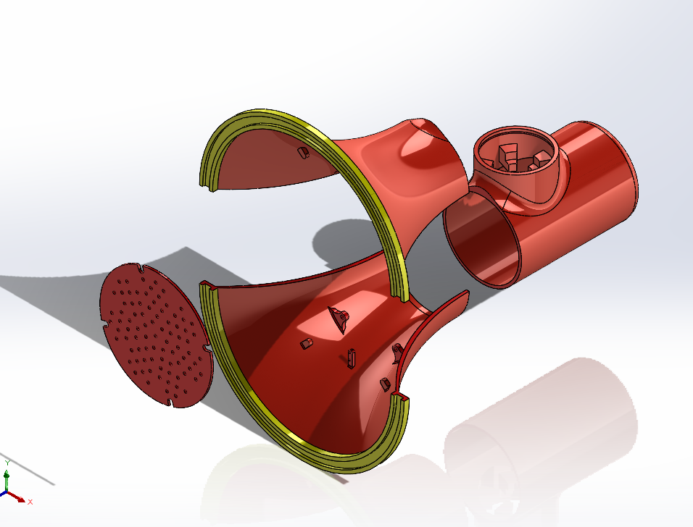

B5.1 Horn

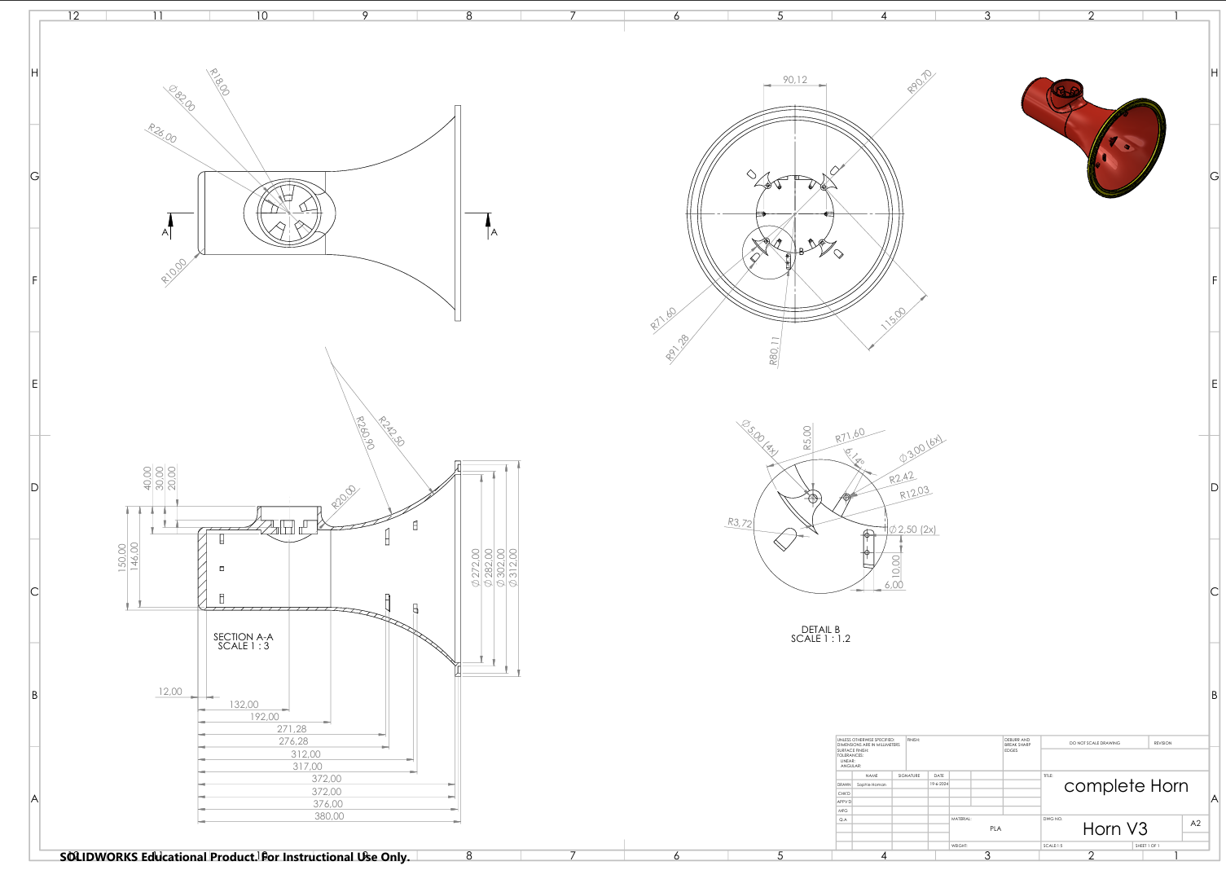

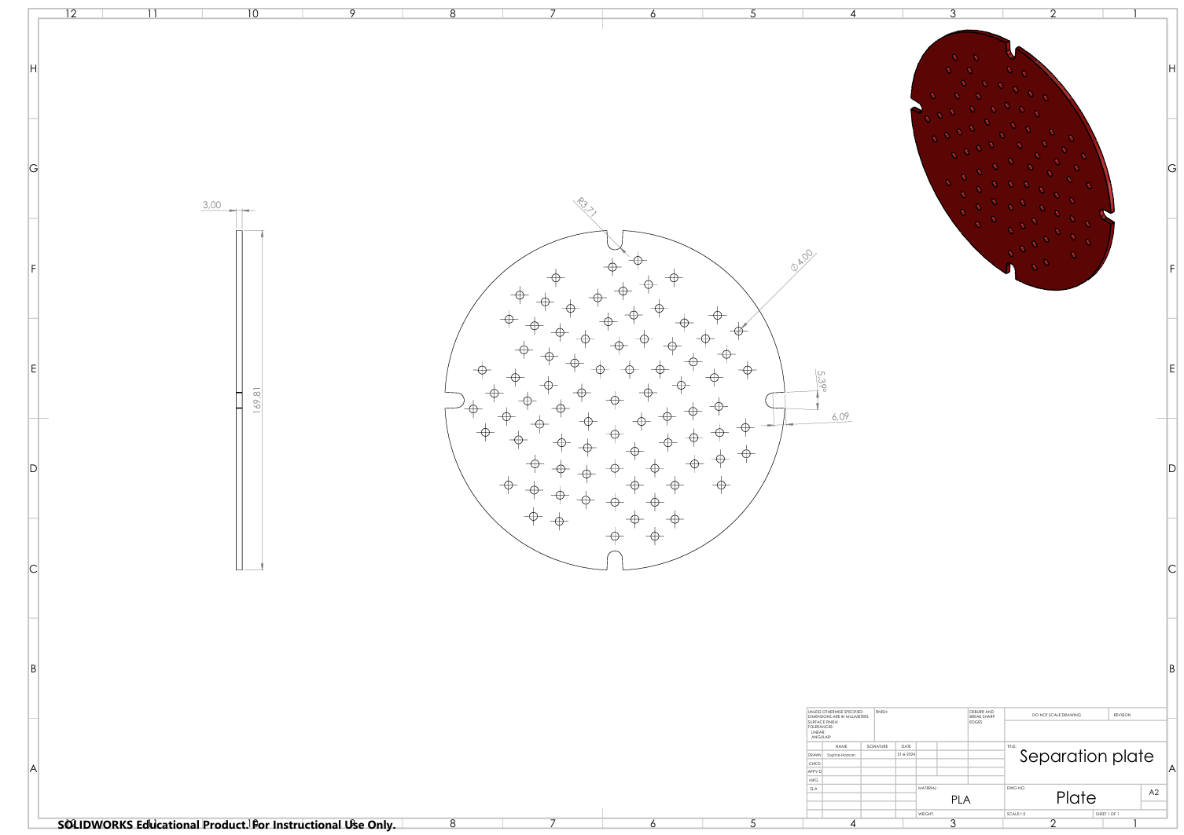

## Appendix C Electrical circuits and PCB designs









## Appendix D BOM & costs

|  |  |  |  |  |  |  |
| --- | --- | --- | --- | --- | --- | --- |
| **Type** | **Model** | **Description** | **Quantity** | **Current Supplier** | **Price** | **Total price** |
| Speaker | FR 10 HMP | Water resistant speaker, 20-30 W power, full range, Ø100mm | 14 | RS-group | 17,01 | 238,14 |
| Microphone | MULTICOMP PRO ABM-708 | Unidirectional microphone | 14 | Farnell | 3.75 | 52.5 |
| ESP32 | ESP32-D0WDQ6 | General purpose Controller | 130 | Tinytronics | 5,5 | 715 |
| ICs | LM386MX-1 | Audio amplifyer for output to speaker | 10 | Farnell | 0,856 | 8,56 |
| ICs | TL072IP | OP amp for microphone filtering | 20 | Farnell | 0,778 | 15,56 |
| 12V powersupply | Osram muis 150W | 12 V power supply | 20 | Led-direct | 17 | 340 |
| 3V3 powersupply | n/a | 3v3 powersupply to power ESPs | 130 | Tinytronics | 3 | 390 |
| LED strips |  | Waterproof LED strips (IP65), 60 LEDs p/m, Prijs p/m | 178 | Tinytronics | 10,8 | 1922,4 |
| Router |  | Cheap router which can connect 130 ESPs | 1 | N/a | 35 | 35 |
|  |  |  |  |  |  | **3717,16** |

|  |  |  |  |  |  |  |  |  |  |  |  |
| --- | --- | --- | --- | --- | --- | --- | --- | --- | --- | --- | --- |
| **Type** | **Model** | | **Description** | | | **Quantity** | **Current Supplier** | | | **Price** | **Total price** |
| Nuts & Bolts |  | |  | | |  | N/a | | |  | 0 |
| Binnen buis |  | | Ø 20mm buiten, per meter | | | 164 | Karwei | | | 10,5 | 1722 |
| Buiten buis |  | | Ø 80mm buiten, per meter | | | 164 | Kunstof shop | | | 40 | 6560 |
| Water protection | n/a | | Lak | | | 0 | n/a | | | 0 | 0 |
|  |  | |  | | |  |  | | |  | 8282 |
| PCBs knooppunten |  | 2600 mm^2 | | 125 | JLC PCB | | | 0,3 | 37,5 | | |
| PCBs Hoorn |  | 3182.6 mm^2 | | 12 | JLC PCB | | | 0,7 | 8.4 | | |
| **Type** | **Model** | **Description** | | **Quantity** | **Current Supplier** | | | **Price** | **Total price** | | |
| 3D Filament | Devil-design gray | PLA (in KG) | | 55 | Tinytronics | | | 18 | 990 | | |
| 3D Printer | n/a | Extra 3d printer so we can print something ourselves | | 0 | N/a | | | 0 | 0 | | |
| 3D Print capacity | n/a | Prints are needed, if someone can print for us that would help | | 0 | N/a | | | 0 | 0 | | |
|  |  |  | |  |  | | |  | 1035.9 | | |

## Appendix E Task division

Division of Tasks of the final report

|  |  |
| --- | --- |
| **Part of report** | **Who** |
| Lay out and grammar control | Jolien, Daniel, Tim |
| Preface | Jolien |
| Summary | Jolien |
| List of abbreviations | Daniel |
| Contents | Jolien, Daniel |
| Introduction | Jolien |
| 1. Background | Sophie |
| 1.1 GLOW festival | Sophie |
| 1.2 Fontys BeCreative | Sophie |
| 2. Problem analysis | Tim |
| 2.1 Problem description | Tim |
| 2.2 Research goal | Tim |
| 2.3 Conditions & restrictions | Tim |
| 2.4 Approach | Tim |
| 2.5 Requirements | Tim |
| 3. Concepts & Story | Jolien |
| 3.1 Brainstorming & Fontys BeCreative method | Jolien |
| 3.2 Concepts | Jolien |
| 3.3 Testing & Final Idea | Jolien |
| 3.4 Pipes: 6 concepts | Jolien |
| 3.5 Final concept (whole installation) | Jolien |
| 3.6 Story | Jolien |
| 4. Construction & Development | Sophie, Jolien, Ask, Daniel |
| 4.1 Prototyping | Sophie, Jolien |
| 4.2 Final Installation | Sophie |
| 4.3 Mechanical Design | Sophie, Jolien |
| 4.4 Electrical design | Daniel |
| 4.5 Software | Ask |
| 5. Promotion & Sponsoring | Tim |
| 5.1 Website | Tim |
| 5.2 Sponsorships | Tim |
| 6. Future & Financing | Daniel, Tim |
| 6.1 Preparation Future | Ask, Daniel, Jolien |
| 6.2 Financing | Daniel |
| 7. Conclusion & Recommendations | Ask, Daniel, Jolien |
| 7.1 Conclusion | Jolien |
| 7.2 Recommendations | Ask, Daniel, Jolien |